

SECTION FOR MANUFACTURING:
Capsule (General) Dry Syrup (Beta Lactum)
Tablets & Capsule (Nutraceuticals)
GMP, Import Export & ISO 9001-2015Certiﬁed company Contact Details:
For Manufacturing: 9882570933 For

CAPSULES  Sr. No. Brand/ Generic Composition |  |  | Phar. | Strength
 |  |  | Ref.
1. | Enteric Coated Rabeprazole Sodium and Domperidone (Sustained Release) Capsules | Each Hard Gelatin Capsule contains:  Rabeprazole Sodium  (as Enteric Coated Pellets)  Domperidone  (As Sustained Release Pellets) | IP IP | 20mg 30mg
2. | Omeprazole & Domperidone Capsule IP | Each Hard Gelatin Capsule Contains:  Omeprazole  (as enteric coated granules)  Domperidone  (As Sustained Release Pellets) | IP IP | 20mg 10mg
3. | Pantoprazole Gastro- resistant and Domperidone Prolonged- Release Capsules IP | Each Hard Gelatin Capsule Contains:  Pantoprazole Sodium (as Sesquihydrate)  Eq. to Pantoprazole  (As enteric coated pellets) Domperidone | IP  IP | 40mg 30mg
4. | Esomeprazole Magnesium (EC) and Domperidone Sustained Release Capsules | Each hard gelatin Capsule contains : - Esomeprazole Magnesium Trihydrate Eq. to Esomeprazole  (as Enteric Coated Pellets)  Domperidone  (As sustained release pellets) | IP  IP | 40mg 30 mg
5 | Enteric Coated  Rabeprazole Sodium and Levosulpiride SR Capsules | Each hard gelatin capsule contains:  Rabeprazole Sodium  (As Enteric Coated Pellets)  Levosulpiride  (As sustained release Pellets) | IP IP | 20 mg 75mg
6 | Enteric Coated Pantoprazole Sodium and Itopride Hydrochloride Sustained Release Capsule | Each Hard Gelatin Capsule Contains:  Pantoprazole Sodium (As enteric coated pellets)  Itopride Hydrochloride (As sustained release pellets) | IP IP | 40mg 150mg
7 | Enteric Coated Rabeprazole Sodium and Itopride Hydrochloride Sustained Release Capsule | Each Hard Gelatin Capsule Contains:  Rabeprazole Sodium (As enteric coated pellets)  Itopride Hydrochloride (As sustained release pellets) | IP IP | 20mg 150mg
TEAMWORK MAKES THE DREAM WORK
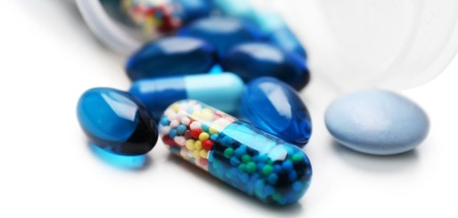

CAPSULES

8 | Enteric Coated Rabeprazole Sodium and Diclofenac Sodium Sustained Release Capsule
8 |  | Each Hard Gelatin Capsule Contains:  Rabeprazole Sodium (As enteric coated pellets)  Diclofenac Sodium  (As sustained release pellets) | IP IP | 20mg 100mg
9 | Itraconazole Capsules BP 100 mg | Each hard gelatin capsule contains:- Itraconazole Pellets  Eq. to Itraconazole | BP | 100 mg
10 | Itraconazole Capsules BP 200 mg | Each hard gelatin capsule contains:- Itraconazole Pellets  Eq. to Itraconazole | BP | 200mg
11 | Pregabalin & Methylcobalamin Capsules IP | Each hard gelatin capsule contains: Pregabalin  Methylcobalamin | IP IP | 75mg 500mcg
12 | Pregabalin & Methylcobalamin Capsules IP | Each hard gelatin capsule contains: Pregabalin  Methylcobalamin | IP IP | 75mg 750mcg
13 | Pregabalin & Methylcobalamin Capsules IP | Each hard gelatin capsule contains: Pregabalin  Methylcobalamin | IP IP | 150mg 500mcg
14 | Pregabalin & Methylcobalamin Capsules | Each hard gelatin capsule contains: Pregabalin  Methylcobalamin | IP IP | 150mg 750mcg
15 | Pregabalin Capsules IP | Each hard gelatin capsule contains: Pregabalin | IP | 100mg
16 | Pregabalin Capsules IP | Each hard gelatin capsule contains: Pregabalin | IP | 150mg
17 | Pregabalin Capsules IP | Each hard gelatin capsule contains: Pregabalin | IP | 225mg
18 | Pregabalin Capsules IP | Each hard gelatin capsule contains: Pregabalin | IP | 300mg

TEAMWORK MAKES THE DREAM WORK

CAPSULES
19 | Methylcobalamine 500mcg + folic acid 1.5mg + alpha lipoic acid 100mg + B6-3mg + Thiamine 10mg capsule | Each hard gelatin capsule contains: Methylcobalamin  Folic Acid Alpha Liopic Acid Vitamin B6  Thiamine hydrochloride | IP IP USP  IP IP | 500mcg 1.5mg 100mg  3mg 10mg
20 | Methylcobalamin1500mcg + Calcium 200mg + Calcitriol 0.25mcg + Folic Acid1.5mg + Pyridoxine3mg Capsules | Each hard gelatin capsule contains: Methylcobalamin  Calcium Calcitriol Folic Acid Pyridoxine | IP IP IP IP | 1500mcg 200mg 0.25mcg 1.5mg 3mg
21 | Omeprazole Capsule IP | Each Hard Gelatin Capsule Contains:  Omeprazole  (as enteric coated granules) | IP | 20mg
22 | Atorvastatin and Aspirin Capsules | Each Hard Gelatin Capsule contains- : Atorvastatin Calcium  Eq. to Atorvastatin Aspirin  (As enteric coated pallets)  Approved colour used in capsule shell | IP IP | 10mg 75mg
23. | Atorvastatin and Aspirin Capsules | Each Hard Gelatin Capsule contains : Atorvastatin Calcium  Eq. to Atorvastatin Aspirin  (As enteric coated pallets) | IP IP | 10mg 150mg
24 | Atorvastatin and Ramipril Capsules | Each Hard Gelatin Capsule contains- : Atorvastatin Calcium  Eq. to Atorvastatin Ramipril  (As enteric coated pallets) Colour : Approved Colour Used  Approved colour used in capsule shell | IP IP | 10mg 150mg
25. | Rosuvastatin, Clopidogrel & Aspirin Capsules | Each hard gelatin capsule contains: Rosuvastatin Calcium  Eq. to Rosuvastatin (In pellets form) Clopidogrel Bisulphate  Eq. to Clopidogrel (In pellets form)  Aspirin (As enteric coated pellets) Excipients  Approved colour used in empty capsule shells & pellets | IP IP  IP | 10mg 75mg  75mg  q.s.
26. | Lansoprazole Gastro Resistant Capsule IP 30mg | Each Hard Gelatin Capsule Contains:  Lansoprazole  (As Gastro resistant pellets) | IP | 30mg
TEAMWORK MAKES THE DREAM WORK

CAPSULES
27. Budesonide Controlled Release Capsules 3mg | Each Controlled Release Capsule Contains:  Budesonide | IP | 3mg
Orlistat Capsules USP 60  28. mg | Each hard gelatin capsule contains Orlistat (as pellets 50% w/w) | USP | 60 mg
29. Orlistat Capsules USP 120 mg | Each hard gelatin capsule contains Orlistat (as pellets 50% w/w) | USP | 120 mg
Diacerein Modiﬁed  30. Release Capsules 100mg | Each capsule contains : Diacerein | IP | 100mg
31. Diacerein Capsules IP 50mg | Each capsule contains : Diacerein | IP | 50mg
32. Thiocolchicoside Capsules IP 8mg | Each Hard Gelatin capsule Contains : Thiocolchicoside Capsules | IP | 8mg
33. Thiocolchicoside Capsules IP 4mg | Each Hard Gelatin capsule Contains : Thiocolchicoside | IP | 4mg
Acelofenac (Sustained Release pellets) &  34. Rabeprazole Sodium (Enteric Coated pellets ) Capsule | Each hard gelatin capsule contains:  Acelofenac  (As Sustained release pellets)  Rabeprazole Sodium  (As Enteric Coated pellets ) | IP IP | 200mg 10mg
Acelofenac (Sustained Release pellets) &  35. Rabeprazole Sodium (Enteric Coated pellets) Capsule | Each hard gelatin capsule contains:  Acelofenac  (As Sustained release pellets)  Rabeprazole Sodium  (As Enteric Coated pellets ) | IP IP | 200mg 20mg
Acelofenac IP (Sustained Release pellets) &  36. Thiocolchicoside IP (Sustained Release pellets) Capsule | Each hard gelatin capsule contains:  Acelofenac  (As Sustained release pellets)  Thiocolchicoside  (As Enteric Coated pellets ) | IP IP | 200mg  8mg
Acelofenac IP (Sustained Release pellets) &  37 Thiocolchicoside IP (Sustained Release pellets) Capsule | Each hard gelatin capsule contains:  Acelofenac  (As Sustained release pellets)  Thiocolchicoside  (As Enteric Coated pellets ) | IP IP | 200mg 16mg
38 Flupirtine Maleate Capsule | Each hard gelatin capsule contains: Flupirtine Maleate | IP | 100mg
TEAMWORK MAKES THE DREAM WORK

CAPSULES
39 | Cinitapride (Extended Release) & Pantoprazole (Enteric Coated) Capsule | Each hard gelatin capsule contains: Cinitapride Hydrogen Tartrate Eq. to Cinitapride  (As Extended Release pellets) Pantoprazole | IP IP | 3mg 40mg
40 | Cinitapride (Extended Release) & Omeprazole (Enteric Coated) Capsule | Each hard gelatin capsule contains: Cinitapride Hydrogen Tartrate Eq. to Cinitapride  (As Extended Release pellets)  Omeprazole  (As Enteric Coated pellets) | IP IP | 3mg 20mg
41 | Doxycycline HCL & Lactic Acid Bacillus Capsule | Each hard gelatin capsule contains: Doxycycline HCL  Eq. to Doxycycline  Lactic Acid Bacillus 5billion spores | IP | 100mg
42 | Mecobalamin, Alpha Lipoic Acid, Folic Acid & Pyridoxine Hydrochloride Capsules | Each hard gelatin capsule contains: Mecobalamin  Alpha Liopic Acid Folic Acid  Pyridoxine Hydrochloride | IP USP  IP  IP | 1500mcg 100mg 1.5mg  3mg
43 | Fluconazole Capsules IP 150 mg | Each hard gelatin capsule contains: Fluconazole | IP | 150mg
44 | Fluconazole Capsules IP 200 mg | Each hard gelatin capsule contains: Fluconazole | IP | 200mg
45 | Ursodeoxycholic acid Capsule 450mg | Each hard gelatin capsule contains:- Ursodeoxycholic acid | IP | 450mg
46 | Valsartan Capsule 80mg | Each hard gelatin capsule contains: Valsartan | IP | 80mg
47 | Valsartan Capsule 160mg | Each hard gelatin capsule contains:- Valsartan | IP | 160mg
48 | Valsartan and Amlodipine Capsule | Each hard gelatin capsule contains:- Valsartan  Amlodipine Besylate Eq. to Amlodipine | IP IP | 80mg 2.5mg
49 | Tranexamic Acid Capsule 250mg | Each hard gelatin capsule contains: Tranexamic Acid | IP | 250mg
TEAMWORK MAKES THE DREAM WORK

CAPSULES
50 | Tranexamic Acid Capsule 500mg | Each hard gelatin capsule contains:- Tranexamic Acid | IP | 500mg
51. | Pantoprazole (EC) & Levosulpiride (ER) Capsule | Each hard gelatin capsule contains: Pantoprazole Sodium  Eq. to Pantoprazole  (as enteric coated pellets)  Levosulpiride  (As extended release pellets) | IP IP | 40 mg 75mg
52. | Enteric Coated Esomeprazole and Sustained Release Levosulpiride Capsules | Each hard gelatin capsule contains: Esomeprazole Magnesium Trihydrate  eq. to Esomeprazole (as enteric coated pellets)  Levosulpiride  (As sustained release Pellets) | IP IP | 40mg  75mg
53. | Oxaceprol Capsule 200mg | Each hard gelatin capsule contains: Oxaceprol | IP | 200mg
54 | Rosuvastatin, Clopidogrel & Aspirin Capsules | Each hard gelatin capsule contains: Rosuvastatin Calcium  Eq. to Rosuvastatin (In pellets form) Clopidogrel Bisulphate  Eq. to Clopidogrel (In pellets form)  Aspirin (As enteric coated pellets) | IP IP IP | 20mg 75mg 75mg
55 | Mecobalamin, Alpha Lipoic Acid, Folic Acid & Pyridoxine Hydrochloride Capsules | Each hard gelatin capsule contains: Mecobalamin  Alpha Liopic Acid Folic Acid  Pyridoxine Hydrochloride | IP USP  IP IP | 500mcg 100mg 1.5mg  3mg
56 | Esomeprazole (EC) & Itopride (SR) Capsule | Each hard gelatin Capsule contains : - Esomeprazole Magnesium Trihydrate Eq. to Esomeprazole  (As Enteric Coated Pellets) Itopride Hydrochloride  (As sustained release pellets) | IP IP | 40mg 150mg
57 | Acebrophylline Capsules 100mg | Each Hard Gelatin Capsule contains: Acebrophylline | IP | 100mg
TEAMWORK MAKES THE DREAM WORK


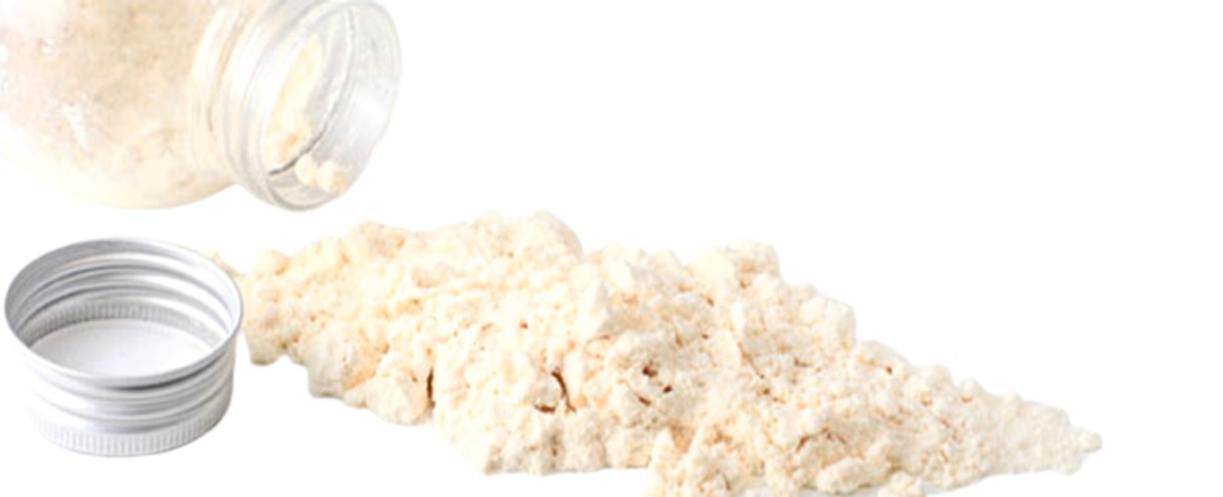


DRY SYRUP

SPACE BIOTEC

SPACE BIOTEC
DRY SYRUP
Sr.  No. | Brand/ Generic | Composition | Phar. Ref. | Strength
1. | Cefixime Oral Suspension IP | Each 5 ml after reconstitution contains Cefixime (As Trihydrate)  Eq. to Cefixime Anhydrous | IP | 100 mg
2. | Cefixime Oral Suspension IP | Each 5 ml after reconstitution contains Cef.ixime (As Trihydrate)  Eq to Cefixime Anhydrous | IP | 50 mg
3. | Cefixime & Potassium Clavulanate Oral Suspension | Each 5 ml after reconstitution contains Cefixime Trihydrate  Eq. to Anhydrous Cefixime Potassium Clavulanate Diluted Eq. to Clavulanic Acid | IP IP | 50 mg  31.25 mg
4. | Cefixime & Potassium Clavulanate Oral Suspension | Each 5 ml after reconstitution contains Cefixime Trihydrate  Eq. to Anhydrous Cefixime Potassium Clavulanate Diluted Eq. to Clavulanic Acid | IP IP | 100 mg  62.5 mg
5. | Cefpodoxime Oral Suspension IP | Each 5 ml after reconstitution contains Cefpodoxime Proxetil  Eq. to (anhydrous) Cefpodoxime | IP | 50 mg
6. | Cefpodoxime Oral Suspension IP | Each 5 ml after reconstitution contains Cefpodoxime Proxetil  Eq. to(anhydrous) Cefpodoxime | IP | 100 mg
7. | Cefuroxime Axetil for Oral Suspension IP | Each 5 ml after reconstitution contains Cefuroxime Axetil (Amorphous)  Eq. to Anhydrous Cefuroxime | IP | 125 mg
TEAMWORK MAKES THE DREAM WORK
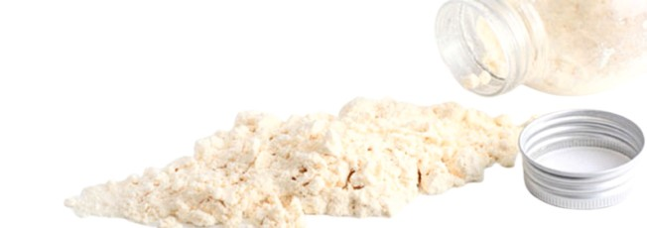

SPACE BIOTEC
DRY SYRUP
08. | Cefpodoxime & Potassium Clavulanate Oral Suspension | Each 5 ml after reconstitution contains Cefpodoxime Proxetil  Eq. to(anhydrous) Cefpodoxime Potassium Clavulanate Diluted Eq. to Clavulanic Acid | IP IP | 50mg 31.25mg
09. | Cefpodoxime & Potassium Clavulanate Oral Suspension | Each 5 ml after reconstitution contains Cefpodoxime Proxetil  Eq. to(anhydrous) Cefpodoxime Potassium Clavulanate Diluted Eq. to Clavulanic Acid | IP IP | 100mg 62.5mg
10. | Cefdinir Oral Suspension IP | Each 5ml of the reconstituted suspension contains: Cefdinir | IP | 250mg
11. | Cefdinir Oral Suspension IP | Each 5ml of the reconstituted suspension contains: Cefdinir | IP | 125mg
12. | Cefprozil For Oral Suspension USP | Each 5ml of the reconstituted suspension contains: Cefprozil Monohydrate  Eq. to Cefprozil | USP | 125mg
13. | Cephalexin Oral Suspension IP | Each 5 ml after reconstitution contains Cephalexin (as monohydrate)  Eq. to Cephalexin Anhydrous | IP | 125 mg
14. | Cephalexin Oral Suspension IP | Each 5 ml after reconstitution contains Cephalexin (as monohydrate)  Eq. to Cephalexin Anhydrous | IP | 250 mg
15. | Cefixime & Ofloxacin Oral Suspension | Each 5 ml after reconstitution contains Cefixime (As Trihydrate)  Eq. to Cefixime Anhydrous Ofloxacin | IP IP | 50 mg 50mg
TEAMWORK MAKES THE DREAM WORK

SPACE BIOTEC
DRY SYRUP
16 | Amoxycillin Oral Suspension IP | Each 5 ml after reconstitution contains Amoxycillin Trihydrate  Eq. to Amoxycillin Anhydrous | IP | 125 mg
17 | Amoxycillin Oral Suspension IP | Each 5 ml after reconstitution contains Amoxycillin Trihydrate  Eq. to Amoxycillin Anhydrous | IP | 250 mg
18 | Amoxycillin & Potassium Clavulanate Oral Suspension IP | Each 5 ml after reconstitution contains Amoxycillin Trihydrate  Eq. to Amoxycillin Anhydrous Potassium Clavulanate Diluted Eq. to Clavulanic Acid | IP IP | 200 mg  28.5 mg
19 | Amoxycillin & Potassium Clavulanate Oral Suspension IP | Each 5 ml after reconstitution contains Amoxycillin Trihydrate  Eq. to Amoxycillin Anhydrous Potassium Clavulanate Diluted Eq. to Clavulanic Acid | IP IP | 400 mg 57 mg
20 | Ampicillin Oral Suspension IP | Each 5 ml after reconstitution contains Ampicillin Trihydrate  Eq. to Ampicillin Anhydrous | IP | 125 mg
21 | Ampicillin Oral Suspension IP | Each 5 ml after reconstitution contains Ampicillin Trihydrate  Eq. to Ampicillin Anhydrous | IP | 250 mg
TEAMWORK MAKES THE DREAM WORK
